Battery Powered Car Air Conditioning

Grant Franklin

Martin Rennaker

Yarentzy Magallanes

**Concept of Operations**

REVISION – 1

8 February 2022

Concept of Operations

for

Battery Powered Car Air Conditioning

Team <31>

Approved by:

Martin Rennaker 02/09/22

_____________________________

Project Leader Date

Starvos Kalafatis 02/09/22

_____________________________

Prof. Date

Sambandh Dhal 02/09/22

_____________________________

T/A Date

**Change Record**

|  |  |  |  |  |
| --- | --- | --- | --- | --- |
| **Rev.** | **Date** | **Originator** | **Approvals** | **Description** |
| **-** | 1/26/2022 | Grant Franklin | Skylar Head | Draft Release |
| **1** | 2/9/2022 | Grant Franklin | Skylar Head | Formatting Revision and Addition of Figures |

Table of Contents

Table of Contents III

List of Tables IV

List of Figures V

1. Executive Summary 7

2. Introduction 7

2.1. Background 7

2.2. Overview 8

2.3. Referenced Documents and Standards 9

3. Operating Concept 10

3.1. Scope 10

3.2. Operational Description and Constraints 10

3.3. System Description 12

3.4. Modes of Operations 13

3.5. Users 13

3.6. Support 13

4. Scenario(s) 13

4.1. Traveling with a Pet 13

4.2. Pre-Boarding Cooling and Heating 13

4.3. Testing Scenarios 14

5. Analysis 14

5.1. Summary of Proposed Improvements 14

5.2. Disadvantages and Limitations 14

5.3. Alternatives 15

5.4. Impact 15

List of Tables

Table 2.1: Estimated Vehicle Interior Air Temperature vs. Elapsed Time……………………7

List of Figures

Figure 2.1: Overview Flowchart………………………..…………………………………….….…8

Figure 3.1: Basic Visualization……..……...…………..…………………………………………11

Figure 3.2: Solar Panel Visualization……...…………..…………………………………………11

Figure 3.3: Subsystem Block Diagram………………..………………………………………...12

# Executive Summary

Our project, Battery Powered Air Conditioning, will allow customers to leave their pets in the car by cooling or warming the car to a safe temperature. Our goal is to construct a device that can cool or warm a crossover SUV without being overly expensive, since most current devices can cost around $500. The device will be controlled with an application that allows the user to adjust and check the temperature on the fly while away from the vehicle. To allow for this long-distance control, the device will be equipped with a sim card as we expect that most cars will be parked in a place without a reliable Wi-Fi signal. The A/C is powered by a battery, so the car does not have to be on while the device is in operation. The exhaust air will be pushed out of the car via a hose hooked to the window to ensure that air is circulating properly. We believe this project will be very useful to people who have pets but who often struggle with bringing them places due to extreme temperatures.

# Introduction

A car parked outside on a sunny, 95-degree Fahrenheit day can reach temperatures of up to 117 degrees Fahrenheit in just 30 minutes. This rapid change in temperature is something many pet owners do not take into consideration when leaving their pets in the car for a seemingly “harmless” trip to the grocery store. We set out to create a device that maintains suitable conditions for man’s best friend inside a parked vehicle without the need to start the engine or use the vehicle's own A/C system. Our battery-powered air conditioning unit will ensure the safety and comfort of the customers pet as well as the peace of mind for costumer.

## Background

A parked vehicle on a hot day can act like a greenhouse, amplifying the heat in the cabin up to 40 degrees Fahrenheit compared to the temperature outside. A table of estimated vehicle interior air temperature can be seen in Figure 2.1. Cracking the windows has little to no effect on these numbers. While a human may be able to withstand these conditions, dogs have limited ways of regulating their body temperature.

The largest organ in the human body is the skin and one marvelous feature of this organ is its ability to perspire to cool our body temperature. While dogs do have sweat glands, they play a minor role in regulating body temperature. Dogs pant, inhaling cool air and exhaling warm air. This makes our K9 friends more susceptible to heatstroke and even death.

The winter weather is not to be neglected. Cars have insufficient insulation to combat against outside conditions. While the vehicle may shelter the pet from the wind and other elements it does not protect them from the frigid temperatures.

|  |  |  |  |  |  |  |
| --- | --- | --- | --- | --- | --- | --- |
| **Estimated Vehicle Interior Air Temperature vs. Elapsed Time** | | | | | | |
| **Elapsed Time (minutes)** | **Outside Air Temperature (°F)** | | | | | |
| 70 | 75 | 80 | 85 | 90 | 95 |
| 0 | 70 | 75 | 80 | 85 | 90 | 95 |
| 10 | 89 | 94 | 99 | 104 | 109 | 114 |
| 20 | 99 | 104 | 109 | 114 | 119 | 124 |
| 30 | 104 | 109 | 114 | 119 | 124 | 129 |
| 40 | 108 | 113 | 118 | 123 | 128 | 133 |
| 50 | 111 | 116 | 121 | 126 | 131 | 136 |
| 60 | 113 | 118 | 123 | 128 | 133 | 138 |
| >60 | 115 | 120 | 125 | 130 | 135 | 140 |

**Table 2.1. Estimated Vehicle Interior Air Temperature vs. Elapsed Time**

## Overview

The Battery Powered Air Conditioning will regulate the temperature in the vehicle, whether it be cooling or heating, to provide optimal conditions for the pet to safely stay in the vehicle unattended. The unit will be powered by a rechargeable battery making it independent and non-reliable on the engine or battery of the car. It will be accessible to the user through an app with features such as increasing or decreasing the climate, real-time readings of the temperature, and turning the device on or off. The internal climate will be read and interpreted by a sensor. That data will be sent and viewed by the user through the application. The user can then set the desired temperature and the A/C unit will output a steady flow of air to match the user's command.

**Figure 2.1. Overview Flowchart**

## Referenced Documents and Standards

* <https://www.akc.org/expert-advice/health/dogs-in-hot-cars/#:~:text=Most%20dog%20owners%20know%20that,at%20risk%20of%20heat%20stroke.&text=The%20answer%20is%20simple%3A%20You,some%20states%2C%20it's%20even%20illegal>.
* <https://www.akc.org/expert-advice/health/leaving-a-dog-in-the-car-in-winter/>
* <https://www.animallaw.info/topic/table-state-laws-protect-animals-left-parked-vehicles>
* I.R. Dadour, I. Almanjahie, N.D. Fowkes, G. Keady, K. Vijayan, Temperature variations in a parked vehicle, Forensic Science International, Volume 207, Issues 1–3, 2011
* F. Belic, Z. Hocenski and D. Sliskovic, "HVAC control methods - a review," 2015 19th International Conference on System Theory, Control and Computing (ICSTCC), 2015, pp. 679-686, doi: 10.1109/ICSTCC.2015.7321372.
* IEEE 1661-2019 Guide for Test and Evaluation of Lead-Acid Batteries Used in Photovoltaic (PV) Hybrid Power Systems
* IEEE/ASHRAE 1635-2018 Guide for the Ventilation and Thermal Management of Batteries for Stationary Applications

# Operating Concept

## Scope

The Battery Powered Air Conditioning project was created because of how detrimental it can be for animals to sit in the car during the summer and winter seasons, where drastic temperature changes occur in a matter of minutes. The objective of this project is to create a machine that can manage the internal temperature of a car using a VAC unit that is controlled by a phone application.

The Battery Powered Air Conditioning will consist of:

* A main unit providing VAC capabilities
* An application that will let the user control the internal temperature
* A microcontroller that receives data from the app and sends signals to the main unit to adjust the temperature based on its temperature sensor
* A battery power supply that can be charged from a solar panel

This project will include subsystems consisting of:

* Power supply selection and design – Grant Franklin
* Application development and connection to main unit – Martin Rennaker
* Microcontroller design and implementation – Yarentzy Magallanes

## Operational Description and Constraints

The Battery Powered Air Conditioning will be used by any pet owner that needs to leave their animal in their vehicle for a substantial amount of time. Once the customer obtains the product, it will be installed to the floorboard of the back seat. They will install a permanent solar panel to the top of the car (Figure 3.2) as well as an application to their phone. After the installation of the solar panels, the user will plug them into the main device with the use of a power cord. This cord will be fed into the vehicle through a small opening of the backseat window secured by a clip. This gap in the window will also clip the exhaust hose of the main unit. (Figure 3.1) Once the device has power, the user will turn on the unit and connect with their cell phone via a sim card. After the unit is on, the customer will use the application to input the desired temperature, and information on their pet. Recommended settings will then appear and a temperature set point will be chosen. At this point, the user can leave their car and is able to adjust the temperature in the car if needed using the application.

The constraints on the project are listed here:

* The device will have to be pet-friendly so the pet will not injure itself, but sturdy enough that the pet cannot damage it
* The main unit will have to fit within the floorboard and single seat of a medium-sized car
* The time that the car will need to heat up will depend on the outside temperature, which varies depending on the location
* The battery will have to last at least two hours so the user will have more than enough time to leave and return to the vehicle

**Figure 3.1. Basic Visualization**

**Figure 3.2. Solar Panel Visualization**

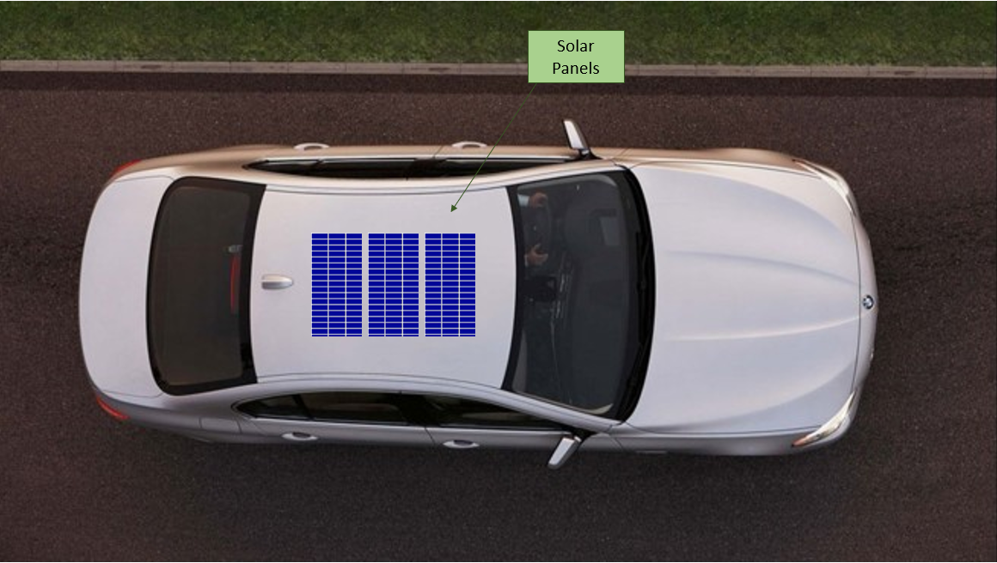

## System Description

As stated in the scope, the project consists of four subsystems: power supply selection and design, application development and connection to main unit, creation of VAC and microcontroller design and implementation. Figure 3.2 shows how the subsystems will work together.

**Figure 3.3. Subsystem Block Diagram**

The responsibilities of the different subsystems are:

* Power supply selection and design – Power will be supplied to the main unit using a solar panel. The user will have to install the solar panels on the top of the vehicle.
* Microcontroller design and implementation – The microcontroller system that will take information from the cell phone application and compare it to data that is showing on its temperature sensor. If the car’s temperature is higher or lower than the user’s desired temperature that is set on the application, the microcontroller will send a signal to the VAC unit to cool or heat the inside of the car.
* Creation of VAC - The VAC system will be built so that the car can be either heated or cooled depending on if the current temperature of the car is hotter or colder than the user’s desired temperature.
* Application development and connection to main unit – The application will allow the user to interface with the microcontroller and send signals through an internet connection. The user will input data on their pet and the desired temperature for the inside of the car.

## Modes of Operations

The project will have two main modes of operation: heating and cooling. Based on the input from the user, the unit will either be set to cool if the current temperature is lower than the desired temperature or heat when the current temperature is higher than the desired temperature.

## Users

The people using our system will primarily be pet owners that have the need to leave their pet in the car for a long amount of time. These customers will most likely be 18+ years old since they must be old enough to drive a car and own a pet. They will not be required to have any training for the installation or operation of our product, since the only thing they will be doing themselves is putting a solar panel on top of their vehicle and downloading and using an application. The information they need will be included in the user’s manual.

## Support

Our product will include a user’s manual that has a description of the device, gives directions on installation, provides information on where to download the application and how to use it, as well as safety warnings involved with the machine. There will also be a section in the manual that will have common questions and answers to those questions.

# Scenario(s)

## Traveling with a Pet

The primary use of the battery powered air conditioning will be to allow pets, specifically dogs, to stay unsupervised and unattended in a vehicle while the driver is away. The battery on the unit will have a duration of 2 hours and will alert the driver when low battery is detected. While conditions are met, the device will cool and heat the car as needed to maintain the ideal temperature for the dog.

## Pre-Boarding Cooling and Heating

Another possible application for the project is to pre-heat or pre-cool the vehicle before the driver and passengers enters it. Using the application, the driver can turn on the A/C from virtually anywhere to prepare for their arrival and have the car warmed up or cooled down internally.

## Testing Scenarios

To ensure our device is working properly, we will perform a series of tests. These tests will encompass the full functionality of our device. Listed below are a few.

* Battery Duration: the device will be left on in its cooling state for 2 hours
* Temperature Sensing: the device will be placed in a room with known temperature. We will then take a reading from the thermostat within the device to assure it matches
* Wireless Communication: the device will be left in a car parked in a lot and a user with the application will be in a nearby building. Commands will be sent via the app and the device response will be observed
* Cooling and Heating: the device will be placed in a hot car and commanded to cool to a certain temperature. Measurements will be made of the temperature of the air being output by the device. This will also be tested in a cold environment while the device outputs warm air
* Drivability: the solar panels will be placed atop the car and driven reaching speeds of up to 60 mph

# Analysis

## Summary of Proposed Improvements

* The device will have solar panels allowing it to last extended periods of time without charging
* The device will be controlled by an app allowing the user to make temperature adjustments while away from the car as well as check the current car temperature to make sure the environment is safe for their pet
* The device will have multiple temperature sensors reducing the likelihood of a malfunction as it will compare the readings and notify the user if one of them is no longer operating correctly
* The device will be cheaper than the alternatives while having substantial improvements

## Disadvantages and Limitations

Limitations of the device are:

* Power supplied will be from solar panels, which will not always be active when there isn’t sunlight, and from a car outlet, which will supply zero voltage if the car battery is dead
* The target car size for cooling will be a crossover sized vehicle, meaning that if the customer wanted to put it in a larger car it may not have the power required to heat/cool that space
* There will be a decent amount of setup required as the user will have to mount solar panels to their roof rack
* There is a slight security risk as the window will be cracked for the exhaust system to work properly. However, this is something we are going to work hard to make as minimal as possible
* The device’s charge will last less time the less the sun is out when the device is in operation

## Alternatives

Alternatives to this device are

* Leaving the car on with another passenger with the animal
* Leaving the pet at home
* Taking the pet into the store

While these are all possible alternatives each of them has a reason why it could not be a viable replacement for our device. None of these allow the customer to safely leave their animal alone in the car without leaving the car on. There are other battery powered A/Cs available, ours hopes to surpass the competition through the improvements mentioned above and by keeping it inexpensive to reach a larger market. One of the best alternatives to our device is the Icy Breeze, this device is much cheaper than having a full VAC system like our device has. The downside to this, however, is that the Icy Breeze must be filled with ice before every use. Our device, having a full VAC system, will simply work anytime it has power.

## Impact

This device’s primary function is to help provide a cool and safe environment for the customer’s pet. Our device is sustainable due to our use of solar panels. These solar panels will operate while sunlight is available and will allow the user to go longer stretches of time without charging. This is important because leaving your car on produces CO2, a greenhouse gas, which contributes to global warming and is generally bad for the environment. The batteries in our device will also be rechargeable to prevent the waste from disposing of batteries in landfills. This device also promotes the companionship between pet owners and their pets by allowing them to take their furry friend wherever they go.